Brimestone Academy Inc. welcomes you and your children with the grace of our Lord Jesus Christ to have an opportunity to become a co-educator entrusted to us as partners in growth and learning.
BSA acknowledge from their immediate environment which is your home and community as they enter in our school. Behaviors, beliefs, aspirations, customs, personality traits, attitudes and how he feels about school can largely be traced back to you.
- Rev. Dr. Bobby M. Brimon | Principal and President
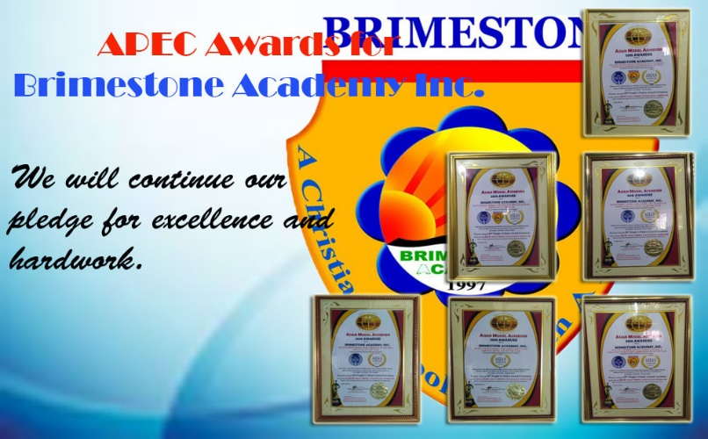
SOME SCHOOL ACHIEVEMENTS
Brimestone Academy Inc. received various awards during the 38th People’s Choice Award Ceremony (Asia-Pacific Award Council, Inc.) such as Outstanding Model for Trusted Private School, Outstanding Model For Christian Academics and etc.
Medalist in City Meet 2019
Medalist in Mathematics Encounter 2019 of APSCI
VISION
A GLOBALLY RECOGNIZED BEST CHRISTIAN SCHOOL IN THE FIELD OF LITERATURE, LANGUAGE AND ART, MATHEMATICS AND SCIENCE WITH COMPLETE STATE-OF-THE-ART FACILITIES.

MISSION
BUILD A SOLID CHRISTIAN SCHOOL IMPARTING BIBLE-BASE EDUCATION, CULTIVATE AND TRAIN THE INTEREST, HIDDEM TALENT OF STUDENT, EQUIP AND TRANSFORM STUDENTS TO BECOME USEFUL MEMBER OF THE FAMILY, NEIGHBORHOOD AND CHRISTIAN COMMUNITY

Enrollment Schedule
January 24, 2020 –
Start of Enrollment Reservation

May, 2020 –
Formal Enrollment

5st Placer in APSCI-School Press Conference 2019
Children’s Education

School Facilities
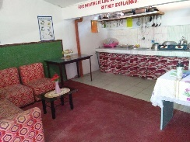
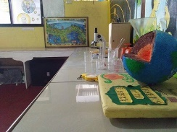

BRIMESTONEAcademy Inc.
“A Christian School With A Mission”
Recognized by the Department of Education
www.bsa-inc.weebly.com
B-44 L-55-65 GPL Annex 1, Malagasang 1-G, Imus City, Cavite
B-18L-13-15Ph. 1, G.E. 2, Malagasang 1-F, Imus City, Cavite

9th Placer in APSCI-Science Encounter 2019

Outstanding Model for Trusted Private School in 38th People’s Choice Award Ceremony

1st Placer and Gold Medalist in APSCI-Mathematics Encounter 2019

Committed for Your

Email Us: customer.brimestoneacademy@gmail.com
Text Us: 09152070070/09462314449

Layout and Publish by BSA-Main Admin. Office
BSA Flier v. 2020-01 | BSA Doc. No. M-0001
Date Published: February 1, 2020
Admission Requirements
*PSA Birth Certificate (Original and Photocopy)
*Form 138 (Report Card)
*Certificate of Good Moral
*2X2 pictures with white background
*Registration Form
*Receipt of Upon Enrollment payment

Note: Enrollees with incomplete admission requirements are temporarily enrolled and required to fill-out our Affidavit of Undertaking.

Admission Procedure
- Enrollees must fill-out the registration form with complete information, thru manual or online in www.bsa-inc.weebly.com/enrollment-and-admission
- Then, enrollees must present the following admission requirements as stated above.
- Secure your Receipt of Payment of Upon Enrollment.
- After processing, the registrar will give you the Student Copy (with indicated “Officially Enrolled”)

Enrollment Reservation
Enrollment Reservation is optional. However, the school offers 35%-20% discounts (with limited slot) in your tuition fee if you reserved. We strictly implement “First Payment, First Serve” in giving this enrollment reservation.

Enrollment Reservation is 1,500.00

Other Fees and Miscellaneous
Miscellaneous Fees
- Upon Enrollment (For ID, -1,500.00
Registration Form and Others)
- Books (Depending on the Grade Level)
- Educational Tour
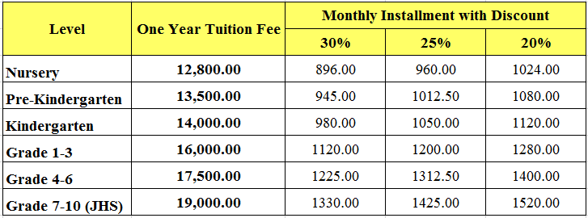
- P. E, Uniform -650.00
- Test Questionnaire Fee (every Examination)
- F. Organizational Fee
- Activity Contribution

Other Services and Offers
- School Service
- Textile (for School Uniform)
- Notebook Covers

Other Tuition Fee Discounts
- Full Payment Upon Enrollment -5%
- Enrollment of Siblings (Discount is ONLY applicable in the Youngest Siblings, Not in all enrolled Siblings)
*Two Siblings -5%
*Three Siblings -20%
*Four Siblings -100%
- Academic Scholarships (for BSA Student Only)
*1st Honor -50%
*2nd Honor -30%
*3rd Honor -20%

NEW TUITION FEE BRACKET APPROVED
BY THE BOARD FOR SY2020-2021
SPECIAL OFFER!!!...
35% for Old Student and 25% for New Student, Discount in Tuition Fee.
All you have to do is to reserve and fully pay the Upon Enrollment and Tuition Fee now.

